**Assessment Project**

By = **Prithviraj Reddy**

* Created a new repository in local **AssessmentProject** and installed git init.
* 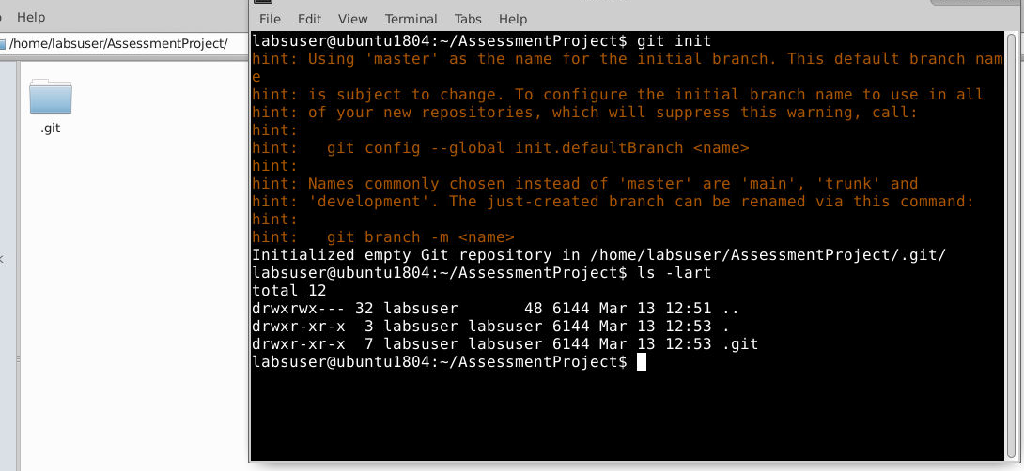
* We are on the master branch
* 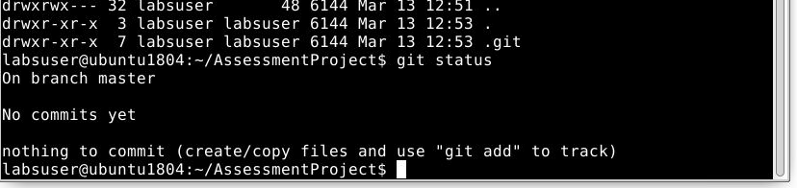
* Created a Test.py file in master branch and committed the file
* 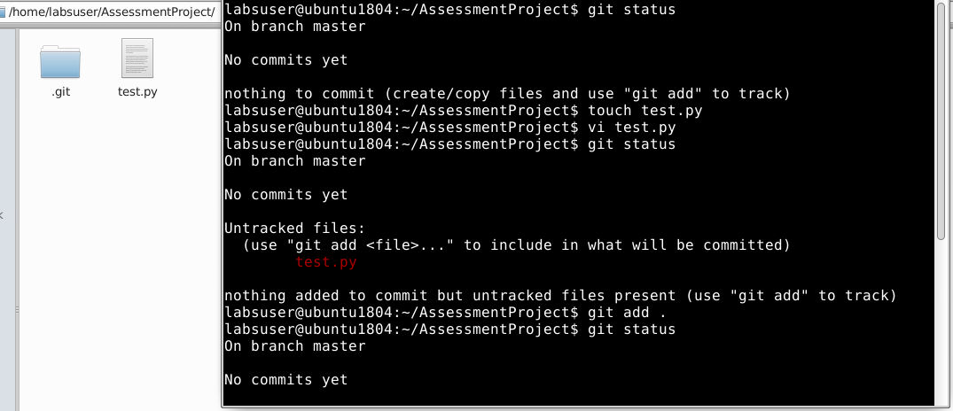
* 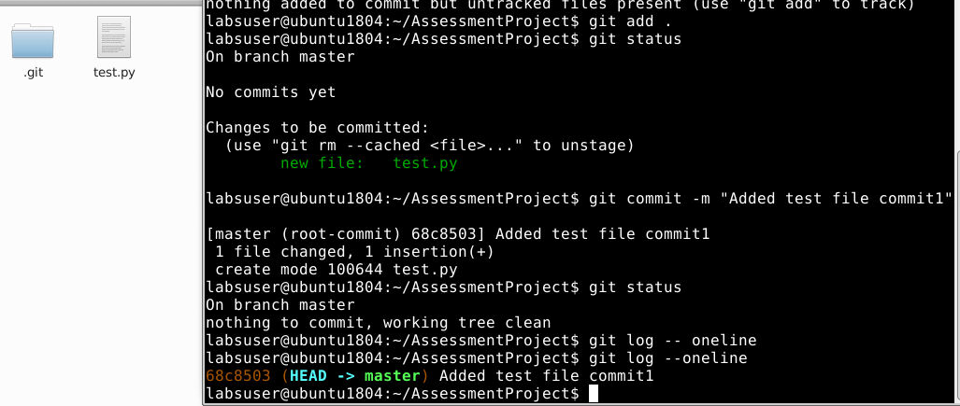
* Created both HotFix and Integration branches
* 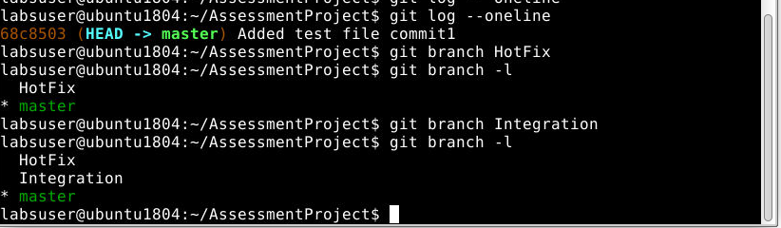
* Added Feature1 and Feature2 branches and integrated with Integration branch
* 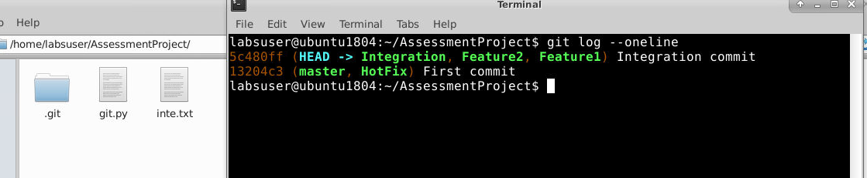
* Added a file to feature2 branch
* 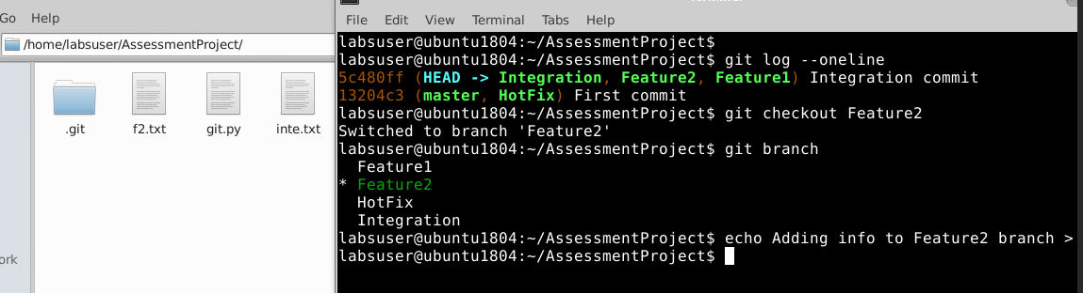
* Merged the feature2 branch into Integration branch
* 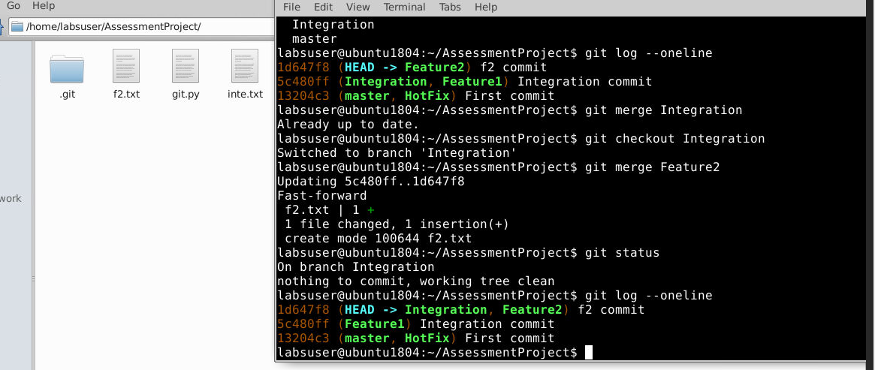
* Deleted the feature2 branch
* 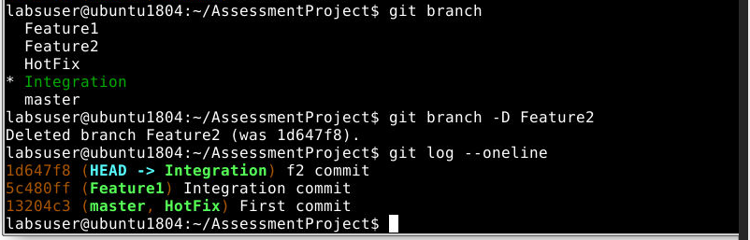
* Added a file to feature1 branch and rebased it with integration branch.
* 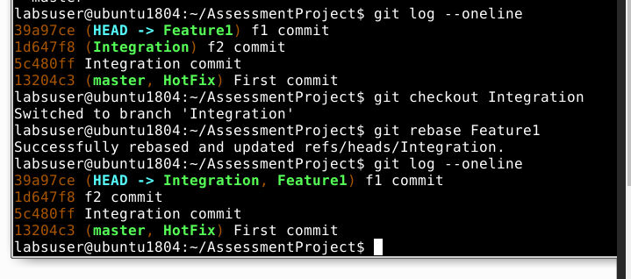
* Merged the Integration branch with HotFix branch.
* 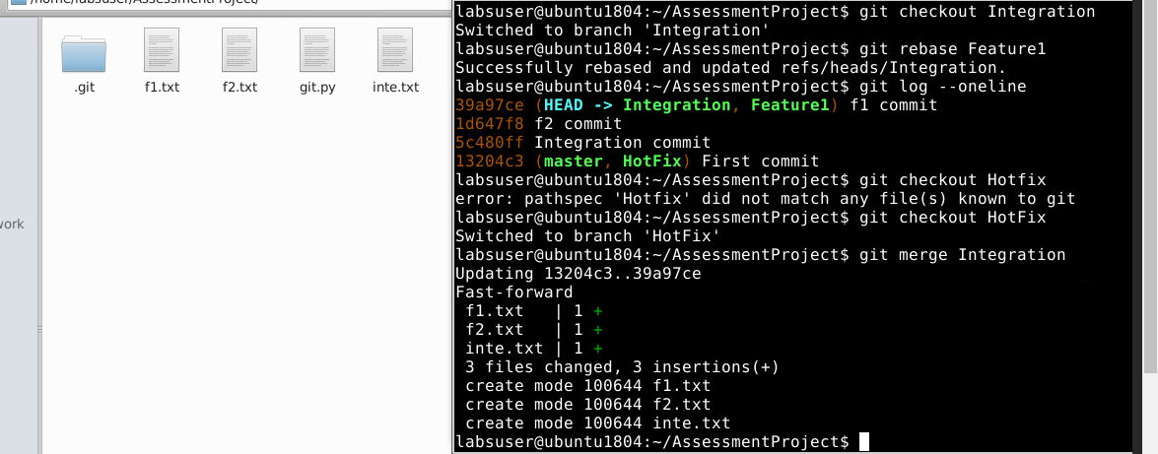
* Merged the integration branch with master branch.
* 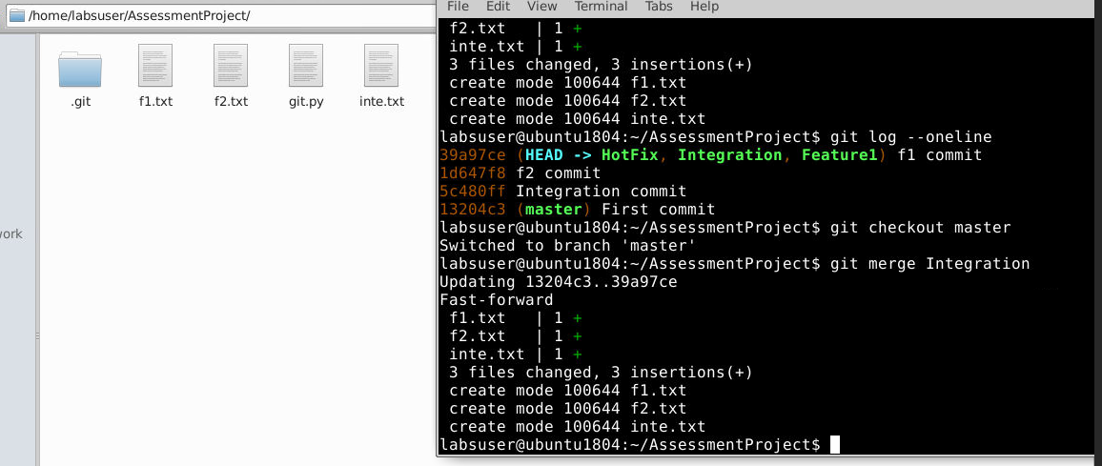
* 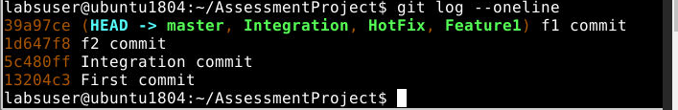
* Committed some changes to feature1 branch
* 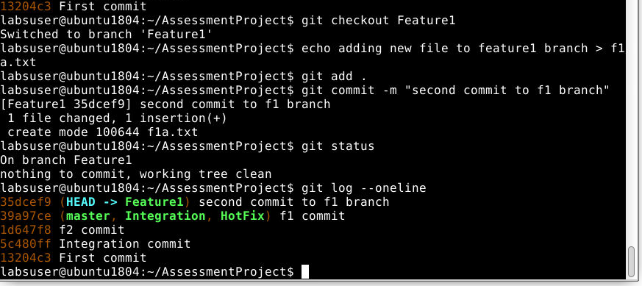
* Merged the new commit from feature1 branch to Integration branch.
* 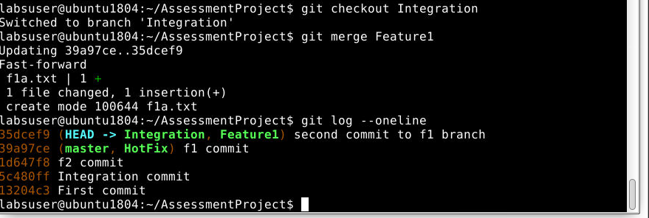
* Merged the new commit from feature1 branch to HotFix banch.
* 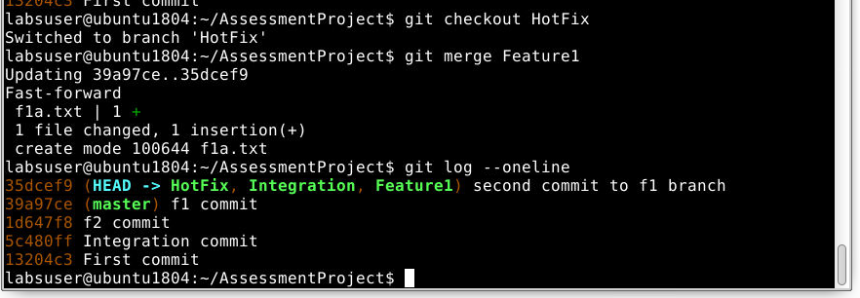
* Merged the new commit from feature1 branch to master banch.
* 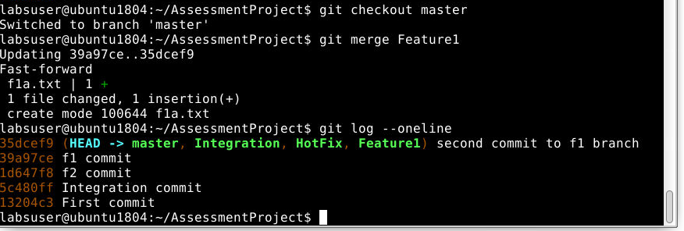
* Deleted the feature1 branch after merging new commit to Integration, HotFix and master branches.
* 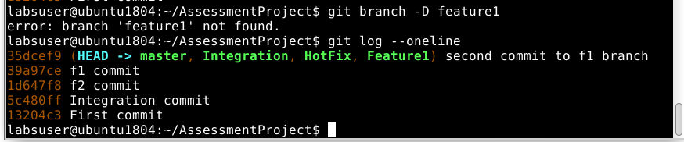
* Committing changed to HotFix branch ang merging the changes to Integration and master branch.
* 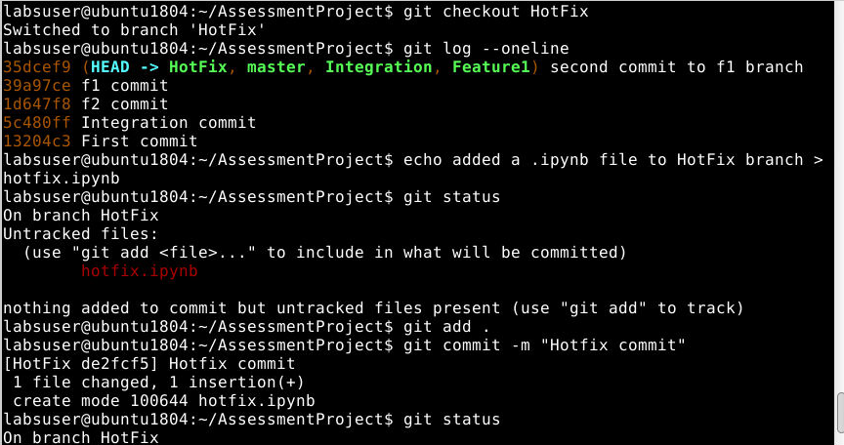
* 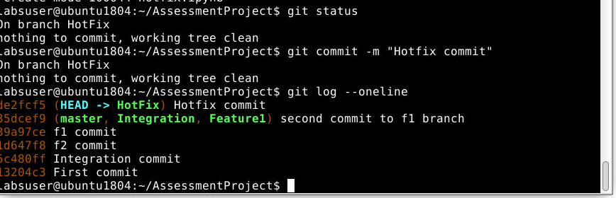
* Merging HotFix branch to Integration branch.
* 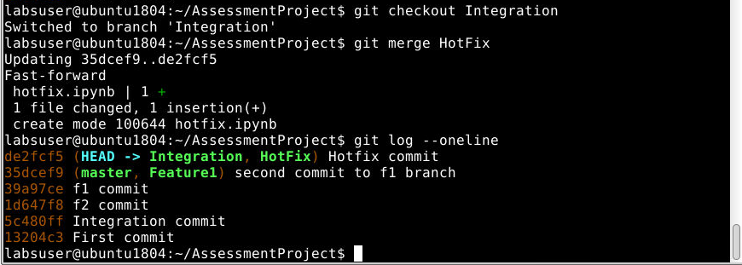
* Merging HotFix branch to master branch.
* 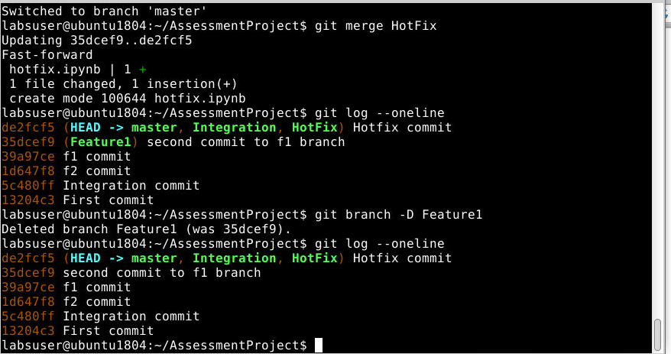
* End of assignment branching development model